|  |  |  |  |
| --- | --- | --- | --- |
| **COURSE NAME / CODE** | | | BTEC National Subsidiary / Diploma / Extended Diploma in IT |
| **UNIT(s) No / Name** | | | Unit 6 – Software development |
| **LEVEL** | 3 | Assignment No & Title | Assignment 1/The Language and Design workshop |

|  |  |  |  |  |  |
| --- | --- | --- | --- | --- | --- |
| **LECTURER/ASSESSOR** | Emmanuel Oladipo/ | | | | |
| **ISSUE DATE** | 28/09/2015 | **DEADLINE DATE** | | 28/10/2015 | |
| **SUBMISSION DATE** |  | |  | | |
| **RESUBMISSION AUTHORISATION**  BY LEAD INTERNAL VERIFIER* |  | | **Authorisation Date (By iv)** | |  |
| **RESUBMISSION DATE\*\*** |  | |  | | |

|  |
| --- |
| **\***all resubmissions must be authorised by the **Lead Internal Verifier**. Only **one** resubmission is possible per assignment, providing:   * The learner has met the initial deadlines set in the assignment, or ha met an agreed deadline extension * The tutor considers that the learner will be able to provide improved evidence without further guidance * Evidence submitted for assessment has been authenticated and accompanied by a signed and dated declaration of authenticity by the learner   **Any resubmission evidence **must** be submitted within 10 working days of receipt of assessment |

**Student declaration**

*I declare that this assignment is all my own work and the sources of information and material I have used (including the internet) have been fully identified and properly acknowledged as required.*

|  |  |
| --- | --- |
| **STUDENT NAME** | **SIGNATURE** |
|  |  |

**ASSESSMENT DETAILS & GRADING CRITERIA**

(NB: Columns 1 &2 of the table below will be completed once the assignment has been submitted) Please note that criteria & evidence should be aimed to give the learner the maximum grade available within their qualification (i.e. A, Pass, Distinction)

|  |  |
| --- | --- |
| **Learning Aims Covered** | |
| LO1 | Know the features of programming languages | | | | | | | | |
| L02 | Understand the principles of software design | | | | | | | | |
| L03 | Be able to use tools to demonstrate software designs | | | | | | | | |
| **GRADING CRITERIA FOR TASK** | | **EVIDENCE** | **EVIDENCE SEEN** | | **Page No#** | **CRITERIA MET** | | | |
| **Y** | **N** | **Y** | **I** | **N** | **IV** |

|  |  |  |  |  |  |  |  |  |  |
| --- | --- | --- | --- | --- | --- | --- | --- | --- | --- |
| P1 | Describe the application and limits of procedural, object oriented and event driven programming paradigms | **Task1**: **instructional report** or **presentation** detailing 3 main points on programming paradigm stated under the P1 subheading |  |  |  |  |  |  |  |
| P2 | Describe the factors influencing choice of programming languages | **Task1**: The same **instructional report** or **presentation** must contain at least 3 main factors listed under P2 subheading |  |  |  |  |  |  |  |
| P3 | Explain sequence, selection and iteration as used in computer programming | **Task2**: The same **instructional report** or **presentation** must contain all the programming concepts listed under **P3 subheading** |  |  |  |  |  |  |  |
| P4 | Outline the benefits of having a variety of data types available to the programmer | **Task 2**: **Table** or **report** detailing **at least 6 data types** and their **uses** |  |  |  |  |  |  |  |
| P5 | Explain the role of softwa  re design principles and software structures in the IT Development Life Cycle | **Task 2**: **A diagram of development life cycle** and a detailed **report of at least 6 software structures** from **P5 subheading** |  |  |  |  |  |  |  |
| M1 | Explain the importance of the quality of code | **Task 2**: A **report** on the importance of quality of code |  |  |  |  |  |  |  |
| D1 | Discuss the factors that can improve the readability of code | **Task 2**: A **report** on at least 3 factors which determine the quality of code |  |  |  |  |  |  |  |

**KEY: Y = Yes, I = Incomplete, N = No**

**BREAKDOWN OF HOW GRADES WILL BE AWARDED:**

(NB: Please tick as appropriate)

|  |  |  |
| --- | --- | --- |
| **TYPE OF QUALIFICATION** | **TICK** | **DESCRIPTION** |
| **BTECS / WORKSKILLS** | **√** | Pass / Merit / Distinction / Fail |
| **A LEVELS / A2** |  | A-U |

**Internal Verification of Assignment Brief**

|  |  |  |  |  |  |
| --- | --- | --- | --- | --- | --- |
| **IV Full Name** |  | **Signed** |  | **Date:** |  |
| **LIV Full Name** |  | **Signed** |  | **Date:** |  |



**BTEC Sample Material**

**Learner Consent Declaration**

|  |  |  |
| --- | --- | --- |
| **Centre No & Name** | **51330 – UTC Reading** | |
| **Subject & Level** | **BTEC National Subsidiary / Diploma / Extended Diploma in IT** | **3** |
| **Unit No & Title** | **Unit 06** /Software development | |
| **Learner No & Name** |  | |

I agree to the learner work identified above, after having been made anonymous, being used to support any of the following activities, which may involve the display of work online through the BTEC website or through publications:

* Professional Development and Training
* Centre Assessment Example Material
* Standardisation Support
* Publication Materials

|  |  |
| --- | --- |
| **Assessor Signature** |  |
| **Name** (block capitals please) |  |
| **Job Title** |  |
| **Date**: |  |

|  |  |
| --- | --- |
| **Learner Signature** |  |
| **Name** (block capitals please) |  |
| **Parent/Guardian consent if under 16 years of age** |  |
| **Date**: |  |

Please ensure that this sheet is completed on submission of your assignment.

Unit: 6

*Software Design and Development*

Assignment:

1. *Which language? 2. Design workshop*

Please note that your assignment **MUST** have the following:

1. Cover page
2. Contents page
3. Introduction
4. Conclusion
5. Bibliography

**SCENARIO** You are a Manager in a small but growing Programming firm. You are in the middle of hiring trainee software engineers and software developers to your firm. You need to prepare training materials to educate your trainees on different Programming Languages.

**TASK 1 You have been asked to create an instructional report**

**(P1) *Report or presentation*** *explain the typical uses of* ***object-orientated****,* ***procedural*** *and* ***event-driven*** *programming languages for our firm, how they can all be combined and why they are each important. Explain the difference between* ***scripting*** *and* ***mark-up*** *languages, examples of each and example uses of.*

*Annotated* ***print screens*** *of code in these languages would be an advantage – especially if they are examples of your own work*

**(P2) *In the same******Report or presentation,*** *discuss the ways and factors we use when we* ***choose the right programming language*** *for a particular task – give at least 5 specific examples, e.g. ‘a basic Webpage should be programming in HTML because . . . . ‘Research other firm’s choices e.g. ‘Microsoft uses C and Visual Basic because . . . ‘*

**TASK 2**  You have been asked to add an appendix to your report to aid your new trainee software engineers. They need to be taught some basic programming concepts including FOR loops, DO Loops, Variables, Arrays, input, output, logical operators, selection operators, IF. . . THEN. . . ELSE and different data types. They also need to understand the design and development life cycle model and the software structures that can be used by a software engineer. Add an appendix to help the trainees learn.

**(P3)** *Include annotated programs or snippets of programs that you have made in your preparation for this assignment to help explain the different programming concepts (detailed above)*

**(P4)** *Using a table or report, explain what data types are available in Visual Studio and what they are used for. Make sure that you detail at least* ***six*** *data types.*

*Explain how you chose the right data type for a variable, why it is important to make the right choice and what happens if you make the wrong choice.*

*Consider the different ways of representing different numbers.*

**(P5)** Explain the Systems Lifecycle and where and how design fits into the model when designing software

In this section of the manual you should explain the different software structures that a software engineer can use;

functions,

procedures,

classes,

objects,

attributes,

methods

Ensure that you specify the different tools used in the design stage

**instruction manual – M1 / D1**

Discuss all the different ways of ensuring good quality code and give examples and also discuss how code can be made more readable (e.g. comments and good use of variable names)

M1 - Explain why it is important to create code of a high quality and the different ways we can make sure this happens. Describe how quality of code can be improved (use annotated examples)

D1 - Discussion of how the software engineer can make the code easier to read (with annotated examples)

|  |  |
| --- | --- |
| **FOR THE PASS CRITERIA** | |
| **P1** | Report or presentation detailing the three different programming paradigms |
| **P2** | Report or presentation detailing what factors influence the choice of programming language through the examples list above |
| **P3** | Report or presentation explaining the different programming concepts listed in Task 2 |
| **P4** | Table or report detailing the data types |
| **P5** | Part 1 of instruction manual – what the systems lifecycle is and how it is applied when designing software |
| **M1** | Part 2 of instruction manual – importance of quality code. Including the various ways that code can be improved. Examples should be given. |
| **D1** | Part 2 of instruction manual - how a software engineer can make their code easier to read with examples to illustrate point. |

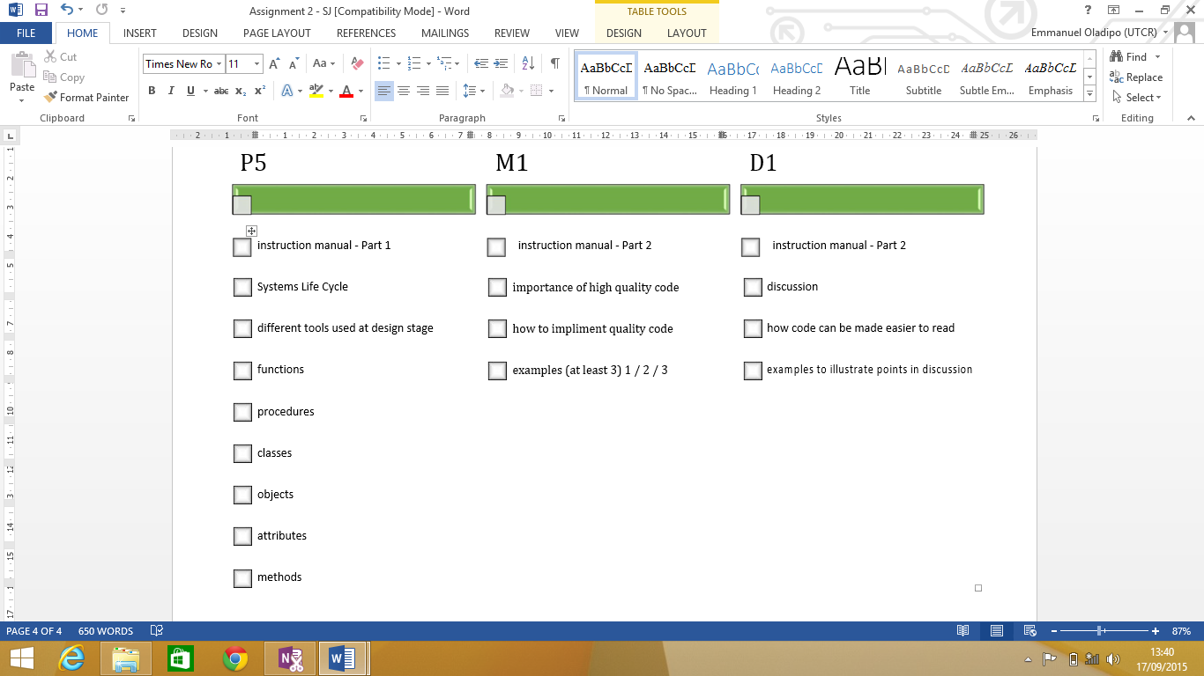

**Textbooks**

1. Bowman K – *Systems Analysis: A Beginner’s Guide* (Palgrave Macmillan, 2003) ISBN-10 033398630X, ISBN-13 978-0333986301

2. Flanagan D – *JavaScript Pocket Reference, 2nd Edition* (O’Reilly, 2002) ISBN-10 0596004117,

ISBN-13 978-0596004118

1. Knuth D – *The Art of Computer Programming: Volumes 1–3, 2nd Edition* (Addison Wesley, 1998)

ISBN-10 0201485419, ISBN-13 978-0201485417

1. Wang W – *Visual Basic 6 for Dummies* (John Wiley & Sons, 1998) ISBN-10 0764503707,

ISBN-13 978-0764503702

1. Wender K – *Cognition and Computer Programming* (Ablex Publishing Corporation, 1995)

ISBN-10 1567500951, ISBN-13 978-1567500950

1. Willis T, Crossland J and Blair R – *Beginning VB.NET, 3rd Edition* (John Wiley & Sons, 2004)

ISBN-10 0764556584, ISBN-13 978-0764556586

**Websites**

www.guidetoprogramming.com/joomla153

www.profsr.com

www.vbexplorer.com/VBExplorer/VBExplorer.asp

visualbasic.about.com

|  |  |  |  |  |  |  |
| --- | --- | --- | --- | --- | --- | --- |
| **SUMMATIVE ASSESSMENT RECORD SHEET** | | | | | | |
| **Programme** |  | | **Learner Name** |  | **Assessor Name** |  |
| **Unit No. & Title** |  | | **Target Learning Aims** |  | **Issue Date** | Click here to enter a date. |
| **Assignment No & Title** |  | | | | **Final Submission Date** | Click here to enter a date. |
| **Target criteria** | **Criteria Achieved** | **Final Assessment Comments** | | | | |
|  |  |  | | | | |
|  |  |  | | | | |
|  |  |  | | | | |
|  |  |  | | | | |

|  |  |  |  |
| --- | --- | --- | --- |
| **Summative comments** | | | |
|  | | | |
| **Assessors declaration** | | | |
| I certify that the evidence submitted for this assignment is the student's own and the learner will be able to provide improved evidence without guidance. I understand that any false declaration is a form of malpractice. | | | |
| **Resubmission authorisation\*** |  | **Resubmission Date:** | Click here to enter a date. |
| * All resubmissions must be authorised. Only 1 resubmission is possible per assignment. | | | |
| **Assessor Signature** |  | **Date:** | 12 May 2016 |
| **Learner comments** |  | | |
| **Learner Signature** |  | **Date:** |  |